# EMS Vehicle Allocation in Cheyenne – Initial Cluster Results

**Hannah Guthrie, MS in Applied Statistics, May 2022**

In the City of Cheyenne, both the Cheyenne Fire Department (CFD) and American Medical Response (AMR) respond to emergency service (EMS) calls. In 2021, out of the 10,000 calls for service the CFD responded to, 7,000 were for EMS [[1](https://bloximages.chicago2.vip.townnews.com/wyomingnews.com/content/tncms/assets/v3/editorial/5/86/5863965c-5818-5bca-9768-af199476c994/620efa96db81e.pdf.pdf)]. When an EMS call is placed and both CFD and AMR respond, the citizen effectively pays doubly as their taxes fund CFD and they will have to pay for the privatized AMR services. To minimize these costs and address this issue, it has been suggested that the City of Cheyenne consider only utilizing the CFD for responding to EMS calls. To make this strategy cost- effective, it’s desired to have additional ambulances placed outside of fire stations in strategic locations across the city to reduce response time and minimize costs (by removing the need for AMR).

For this analysis, data comprising of census block ID, and latitude/longitude coordinate locations of properties in each census block for the City of Cheyenne were used to create all combinations of travel time duration between each census block. Properly allocated clusters will minimize drive time (limiting the same vehicle from traversing the edges of the city). Proposed EMS locations using Partitioning Around Medoids (PAM) on Euclidean Distance, and Hierarchical Clustering on travel time duration to establish these regions are illustrated in Figures 1 and 2, with average response time for each specified region/cluster depicted in Table 1 and 2.

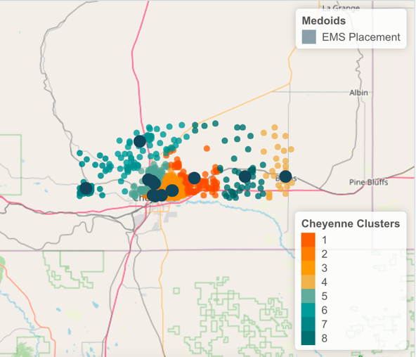

Figure 1: PAM Clusters Map

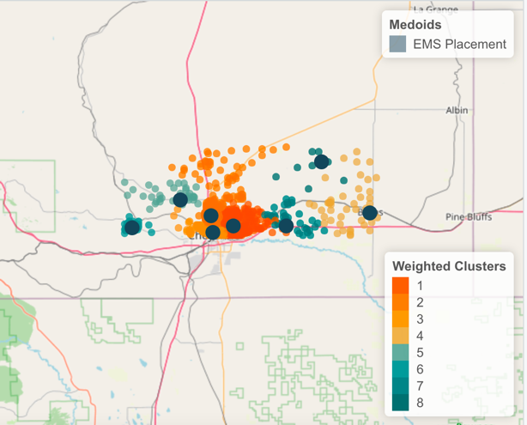

Figure 2: Hierarchical Clusters Map

Table 1: PAM Response Times

Table 2:Hierarchical Cluster Response Times

From these results, clustering weighted towards travel time duration yields a faster response time than Euclidean distance, except for clusters 2 and 5. The clusters numbers do not indicate the same cluster in both methods; the shift of location and spread of the clusters from the PAM clustering to travel-time based clustering is most apparent in northern and eastern Cheyenne. This more drastic shift compared to other more central and western areas of Cheyenne is likely due to the accessibility of these areas through major roadways like I-25 and I-80, as well as the limited, efficient routes to different locations in these areas; to properly be serviced, the region needs to be condensed. This overall faster response time is an unsurprising result as these clusters were generated in a manner respecting travel times. As such, census blocks with similarity in travel time from a central location would be clustered together, as these census blocks would have proximity in location to similar accessible and viable travel routes in Cheyenne. The more efficient clusters generated by hierarchical clustering should be employed, going forward.